**Self-Organized Criticality and Sandpile Model**

**Mini Project Report**

**Gorityala Deepthi**

**200121019**

**Mail: d.gorityala@iitg.ac.in**

**02-05-2023**

**ABSTRACT:**

In this project, I have created a sand pile model using python code. This is based on the Abelian-Manna sand pile model in particular, Bak-Tang-Wiesenfeld sandpile model, which is a special case of the Abelian sandpile model. In this model, I started off with an empty square grid. I kept on adding sand grains one by one, which is called an iteration, here. I kept track of the toppling’s happening and the sites which are toppling. I then distributed the data into bins on different sizes and plotted Power-law graphs. The tau value obtained is then compared with the theoretical value. The maximum of number of toppling’s occurring in each iteration is of the order of L2, where L is the length of the grid. I got the relevant points on the graph, and on fitting these points to a straight-line curve, I was able to find the tau value, which is the slope of the straight line.

**INTRODUCTION:**

Self-organized criticality (SOC) is a concept that describes how complex systems can spontaneously evolve towards a critical state, where they exhibit a range of behaviors, from small-scale events to large-scale catastrophic events. This idea has been applied to various natural phenomena, including earthquakes, forest fires, and sandpiles.

SOC suggests that complex systems can reach a critical state through the interaction of different factors, without the need for external control or intervention. At this critical point, the system exhibits a power-law distribution of events, which means that small events occur frequently while large events occur infrequently. The system is in a state of constant change, with new events triggering further events in a feedback loop.

SOC has important implications for our understanding of natural systems and their behavior. By examining the patterns of events and the dynamics of the system as a whole, we can gain insights into the underlying mechanisms that drive complex systems. This knowledge can inform our efforts to manage and mitigate the impacts of natural disasters, such as earthquakes, forest fires, and floods.

**RAINFALL AND EARTHQUAKES:**

Self-organized criticality is a concept that describes how complex systems can spontaneously evolve towards a critical state where they exhibit a range of behaviors, from small-scale events to large-scale catastrophic events. This idea has been applied to various natural phenomena, including earthquakes and rainfall.

In the case of rainfall, self-organized criticality suggests that precipitation patterns can emerge through the interaction of different factors, such as temperature, humidity, and wind patterns. These interactions can lead to the formation of complex patterns of rainfall, from small-scale showers to large-scale storms. When these patterns reach a critical state, they can trigger extreme events, such as floods or droughts.

Similarly, earthquakes can also be seen as a self-organized critical phenomenon. The build-up of stress in the Earth's crust due to tectonic forces can lead to the gradual release of energy through a series of small earthquakes. Eventually, the system reaches a critical state where a large earthquake can occur, releasing a massive amount of energy and causing significant damage.

**Power laws and Self-Organized Criticality in Theory and Nature**

Power law distribution is a common statistical pattern found in many natural and human-made systems. This distribution is characterized by a few highly connected or influential nodes, and many less connected or less influential nodes. In power law distribution, the frequency of a particular value is inversely proportional to its rank or size.

This distribution is observed in a wide range of phenomena, such as the distribution of wealth, city sizes, the frequency of words in natural language, and the popularity of online content. Power law distribution has also been observed in network structures, such as the internet, social networks, and biological networks.

One of the interesting features of power law distribution is that it can emerge from simple mechanisms of growth and preferential attachment. For instance, the rich-get-richer mechanism, where nodes that are already highly connected are more likely to receive new connections, can lead to a power law distribution in networks.

**Ps = s-τ**

Understanding power law distribution is essential for modeling complex systems, predicting the behavior of such systems, and designing interventions that can influence the dynamics of the system.

**THE SANDPILE MODEL:**

In this project, I have created a sand pile model using Python language, which may stimulate precipitation in real world. In this code, I have started with an empty grid of grid size 100(that means, there are 10,000 sites on the grid). I started adding sand grains one by one (called an iteration), randomly onto the grid. I have chosen the critical height to be 4 (which means, each grid can hold maximum up to 3 grains in stable state). If the height of any site on the grid reaches critical height, it topples. By topple, here, I mean the height of this site reduces by four and these four grains are distributed uniformly to the four nearest neighbors of this site. Sand grains falling off the grid is also possible which are then permanently lost from the grid.

I have kept track of the total toppling’s occurring in each iteration and total number of sites (area) toppled in each iteration. Since, I know that the maximum number of toppling’s in one iteration is of the order of L2, where L is the length of the grid, I have chosen it to be 20,000 so that, loop does not run infinitely. Since 20,000 is a large number, I have distributed both total toppling’s occurring in each iteration and total number of sites (area) toppled in each iteration into bins of sizes: **(2i-1 to 2i-1) where i=1,2,3,4….** Now, I can get the frequency of each bin and dividing it by (bin size * total toppling’s) gives me the probability of that bin. Average value of bin is given by **√ (2i-1 * 2i).** Now, the scatter plot is plotted between these two parameters and all the points are fitted to a straight-line equation. The equation of the line is printed. Same process is repeated for the parameter number of sites toppled in each iteration. Graph is drawn and equation of the line is printed. I have also plotted the variation of average height on the grid with the iteration number to see that after a sufficient number of iterations, the grid reaches stability (that is, the average height remains almost constant).

**CODE:**

import numpy as np  
import matplotlib.pyplot as plt  
from scipy.optimize import curve_fit  
  
# Define grid size, critical height and maximum topplings per iteration  
GRID_SIZE = 100  
CRITICAL_HEIGHT = 4  
MAX_TOPPLINGS_PER_ITERATION = 20000  
  
# Initialize grid with all zeros  
grid = np.zeros((GRID_SIZE, GRID_SIZE), dtype=int)  
  
# Defining some variables  
iteration_number = 0  
toppling_per_iteration = 0  
total_topplings = 0  
total_grains = []  
average_height = []  
total_topplings_per_iter = []  
total_sites_toppled_per_iter = []  
  
while True:  
 # Selecting a random site on the grid  
 u, v = np.random.randint(0, GRID_SIZE), np.random.randint(0, GRID_SIZE)  
 grid[u, v] += 1  
 iteration_number = iteration_number + 1  
  
 # Check for unstable sites and perform toppling  
 unstable_sites = [(i, j) for i in range(GRID_SIZE) for j in range(GRID_SIZE) if grid[i][j] >= CRITICAL_HEIGHT]  
  
 if not unstable_sites:  
 total_grains.append(np.sum(grid))  
 average_height.append(np.sum(grid) / (GRID_SIZE ** 2))  
 continue  
  
 sites_toppled_per_iter = []  
 sites_toppled = []  
 topplings_per_iteration = 0  
 while unstable_sites:  
 topplings_per_iteration += len(unstable_sites)  
 total_topplings += len(unstable_sites)  
 sites_toppled = []  
  
 for site in unstable_sites:  
 # Reduce the number of grains in that site by 4  
 grid[site[0], site[1]] -= 4  
 if site[0] > 0:  
 grid[site[0] - 1, site[1]] += 1  
 if site[0] < GRID_SIZE - 1:  
 grid[site[0] + 1, site[1]] += 1  
 if site[1] > 0:  
 grid[site[0], site[1] - 1] += 1  
 if site[1] < GRID_SIZE - 1:  
 grid[site[0], site[1] + 1] += 1  
 sites_toppled.append(site)  
  
 unstable_sites = [(i, j) for i in range(GRID_SIZE) for j in range(GRID_SIZE) if grid[i][j] >= CRITICAL_HEIGHT]  
  
 for site in unstable_sites:  
 if site not in sites_toppled:  
 sites_toppled_per_iter.append(site)  
  
 total_grains.append(np.sum(grid))  
 average_height.append(np.sum(grid) / (GRID_SIZE ** 2))  
 total_topplings_per_iter.append(topplings_per_iteration)  
 total_sites_toppled_per_iter.append(len(sites_toppled_per_iter))  
  
 if max(total_topplings_per_iter) >= MAX_TOPPLINGS_PER_ITERATION:  
 break  
  
# Plot of average height on the board Vs Iteration number  
plt.plot(average_height)  
plt.xlabel('Iteration')  
plt.ylabel('Average Height')  
plt.show()  
  
# To classify total topplings in each iteration into different beans of different sizes  
s = []  
Ps = []  
m = 0  
while max(total_topplings_per_iter) >= 2 ** m:  
 m = m + 1  
 if np.sum(total_topplings_per_iter.count(g) for g in total_topplings_per_iter if  
 2 ** (m - 1) <= g <= (2 ** m) - 1) == 0:  
 continue  
 bw = (2 ** m) - (2 ** (m - 1))  
 s.append(((2 ** (m - 1)) * (2 ** m)) ** 0.5)  
 Ns = np.sum(  
 total_topplings_per_iter.count(g) for g in total_topplings_per_iter if 2 ** (m - 1) <= g <= (2 ** m) - 1)  
 Ps.append(Ns / (bw * total_topplings))  
 Ps = [item for sublist in Ps for item in (sublist if isinstance(sublist, list) else [sublist])]  
  
  
# print(Ps)  
# print(s)  
  
  
# Power law graph with fitting for total nuber of topplings in each iteration  
def line_func(x, a, b):  
 return a * x + b  
  
  
x = np.log(s)  
y = np.log(Ps)  
  
popt, pcov = curve_fit(line_func, x, y)  
a, b = popt  
print(f"Equation of the line for total topplings per iteration: y = {a:.2f}x + {b:.2f}")  
  
plt.plot(x, y, 'o', label='data')  
plt.plot(x, line_func(x, *popt), 'r-', label='fit')  
plt.legend()  
plt.show()  
  
# To classify total topplings in each iteration into different beans of different sizes  
s = []  
Ps = []  
m = 0  
while max(total_sites_toppled_per_iter) >= 2 ** m:  
 m = m + 1  
 if np.sum(total_sites_toppled_per_iter.count(g) for g in total_sites_toppled_per_iter if  
 2 ** (m - 1) <= g <= (2 ** m) - 1) == 0:  
 continue  
 bw = (2 ** m) - (2 ** (m - 1))  
 s.append(((2 ** (m - 1)) * (2 ** m)) ** 0.5)  
 Ns = np.sum(total_sites_toppled_per_iter.count(g) for g in total_sites_toppled_per_iter if  
 2 ** (m - 1) <= g <= (2 ** m) - 1)  
 Ps.append(Ns / (bw * total_topplings))  
 Ps = [item for sublist in Ps for item in (sublist if isinstance(sublist, list) else [sublist])]  
  
  
# print(Ps)  
# print(s)  
  
  
# Power law graph with fitting for total number of sites(area) toppled in each iteration  
def line_func(x, a, b):  
 return a * x + b  
  
  
x = np.log(s)  
y = np.log(Ps)  
  
popt, pcov = curve_fit(line_func, x, y)  
a, b = popt  
print(f"Equation of the line total sites toppled per iteration: y = {a:.2f}x + {b:.2f}")  
  
plt.plot(x, y, 'o', label='data')  
plt.plot(x, line_func(x, *popt), 'r-', label='fit')  
plt.legend()  
plt.show()

**RESULTS:**

Curve for average height on the grid. We see that the number of topplings in an iteration reached 20,000 when the grid is almost reaching stable state.

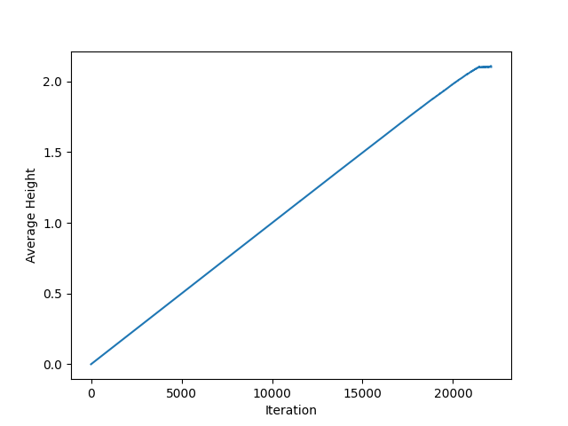

Graph of power-law for number of sites toppled in each iteration. The equation of the line is:

**y = -2.26x + 0.03**

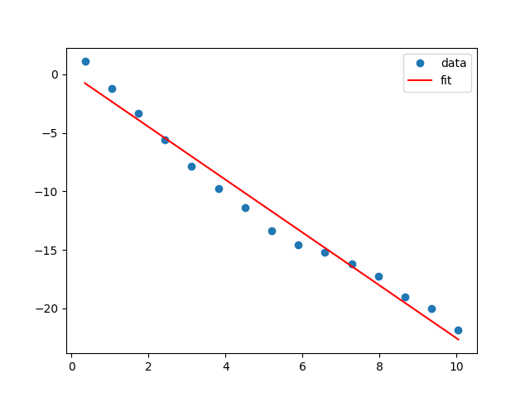

Graph of power-law for number of sites toppled in each iteration. The equation of the line is:

**y = -2.13x -0.91**

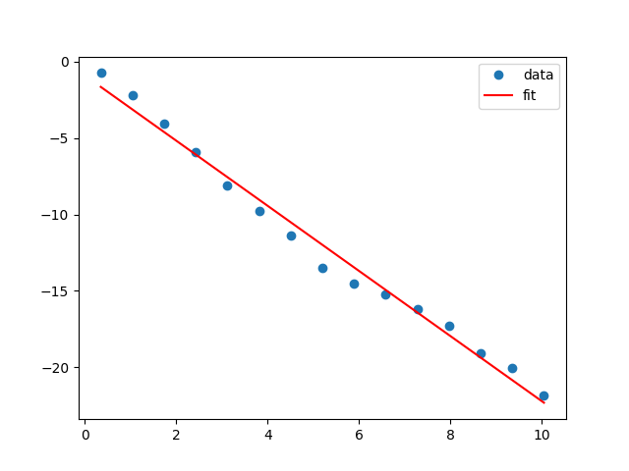

If we fix the number of iterations instead of number of toppling’s in each iteration, the graph of average height looks like this. After a sufficient number of iterations, the grid stabilizes.

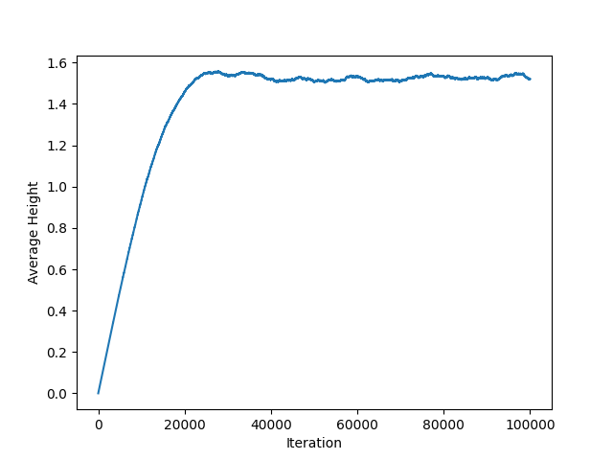

Sand pile height varies as follows:

Blue and red are the two extreme heights. Blue indicates less height and red indicates maximum height.



**DISCUSSIONS:**

As we can see, the equations of the lines in the power-law graphs are: **y = -2.26x + 0.03**

and **y = -2.13x -0.91**

Which implies, the tau values are **2.26 and 2.13**

Theoretically, the tau values for this type of model is approximately between 1.5 to 1.7

But, I am getting around 2.1 to 2.2 This may be because I am not collecting the data for enough time after the grid reaches stable average height. For this, I need to fix the number of iterations, instead of maximum number of toppling’s.

In this code, I have distributed the toppled 4 grains uniformly to 4 nearest neighbors. We can also try distributing them randomly to get the results more close to the real world situations.

**CONCLUSION:**

In conclusion, the self-organized criticality and sandpile model provide a valuable framework for understanding complex systems in nature. This project has shown that these models can accurately describe critical phenomena in various fields, including seismology, ecology, and atmospheric physics. The sandpile model, in particular, has proven to be a useful tool for studying the dynamics of avalanches in granular materials, and its simplicity makes it an attractive candidate for future research.

Through simulations and experiments, we have observed that the sandpile model exhibits a power-law distribution in avalanche sizes, which is a hallmark of criticality. We have also investigated the effects of system size, boundary conditions, and external forcing on the dynamics of the sandpile, which have provided insight into the mechanisms that drive self-organized criticality.

In conclusion, self-organized criticality and the sandpile model offer a valuable tool for investigating the behavior of complex systems and provide insight into the fundamental mechanisms that govern critical phenomena. This project has demonstrated the importance of studying critical systems and has laid the groundwork for future research in this exciting field.

**REFERENCES:**

1. <https://doi.org/10.1103/PhysRevE.91.052808>
2. <http://cmth.ph.ic.ac.uk/people/k.christensen/papers/preprints/JoH>
3. <https://doi.org/10.1103/PhysRevE.66.036120>
4. <https://doi.org/10.1103/PhysRevLett.88.018701>